Lab 10

MOSFET Common Source Amplifier
Name: Syed Sualeh Abbas, Syed Haider Zaidi | Student ID: 10303, 10272

Objective
To investigate the transfer characteristics of MOSFET and characteristics of MOSFET common source amplifier

MOSFET Transfer Characteristics
Consider the circuit shown in Figure 1. Here, an n-channel MOSFET is in common source configuration. If it is viewed as two-port network, the source terminal is common to input and output sides. We have obtained the output characteristic curve (Id as a function of V_{ds}) and the input characteristic curve (I_{d} as a function of V_{gs}) in previous labs. The effect of change in drain current due to change in gate-to-source voltage results in change in drain-to-source voltage when a resistor R_{D} is used as shown in the Figure 1.
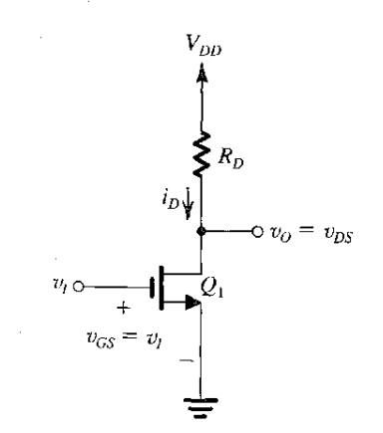
Figure 1: MOSFET in common source configuration
We will use this circuit to determine the relation between its output voltage Vo and its input voltage Vi. These characteristics are called transfer characteristics of MOSFET. The output voltage can be given as:

Task 1: To obtain transfer characteristic curve of n-channel MOSFET
- Use 2N7000 n-channel MOSFET and set V_{DD}=10V. Connect R_{D} equal to 1kΩ to implement the circuit of Figure 1 in PSpice. Connect a separate DC source at input side (gate terminal). Vary this input voltage from 0 to 10V through sweep analysis.
- Obtain transfer characteristic curve i.e., plot of V_{DS} as a function of V_{GS.} Identify and label the regions of operation on the curve and add capture of the labelled plot. Note that the threshold voltage of 2N7000 is 2.14V as determined in previous labs.

CUT OFF:
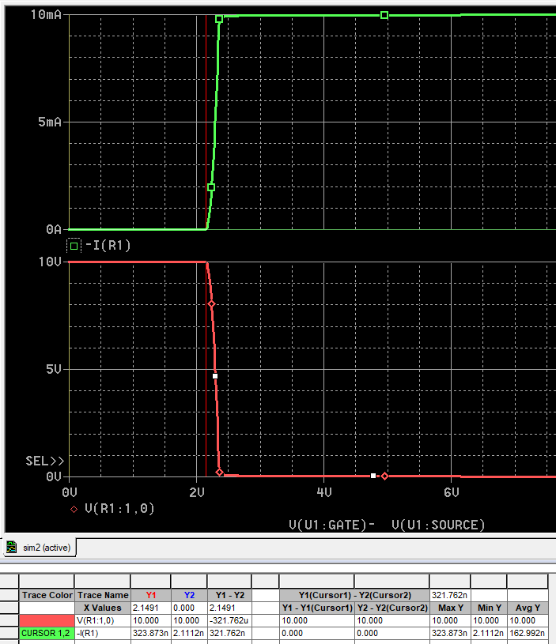
SATURATION:
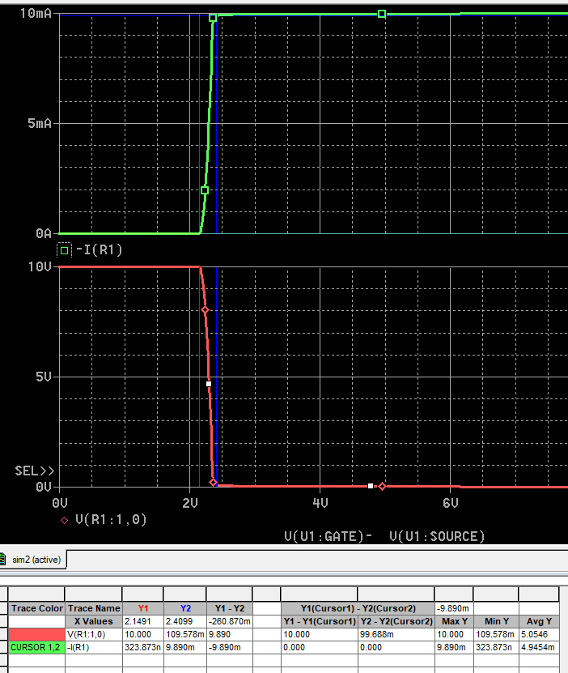
TRIODE REGION:
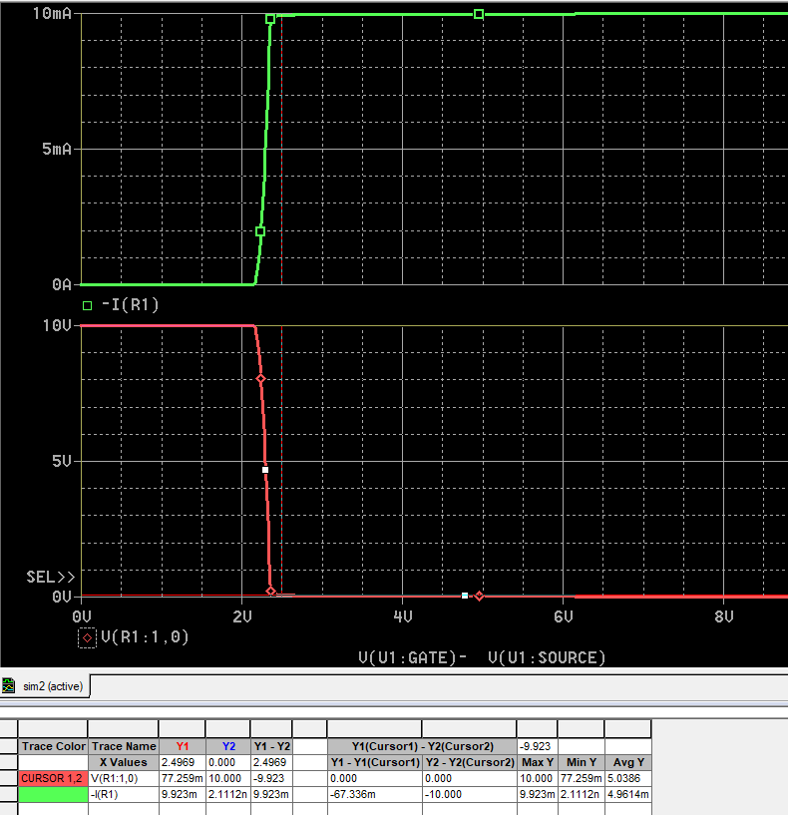

Introduction to MOSFET Amplifier
From the transfer characteristic curve of MOSFET, it can be seen that in saturation region, there is a large variation in drain-to-source voltage for small change in gate-to-source voltage. In this region, MOSFET can be used as an amplifier where small AC signal is superimposed on input gate terminal and output is taken across drain terminal. The basis for this important MOSFET application is that when operated in the saturation region, the MOSFET acts as a voltage-controlled current source: changes in the gate-to-source voltage gives rise to changes in the drain current and using a resistor R_{D,} amplified output voltage Vo is obtained.
This effect of variation in gate-to-source voltage can be related to the change in Q-point in BJT output characteristic curves along load line when small AC signal is superimposed on input base terminal. To operate MOSFET as an amplifier, it is first biased in saturation region such that the DC operating point is at center to allow maximum swing in both directions. This is represented in Figure 2.
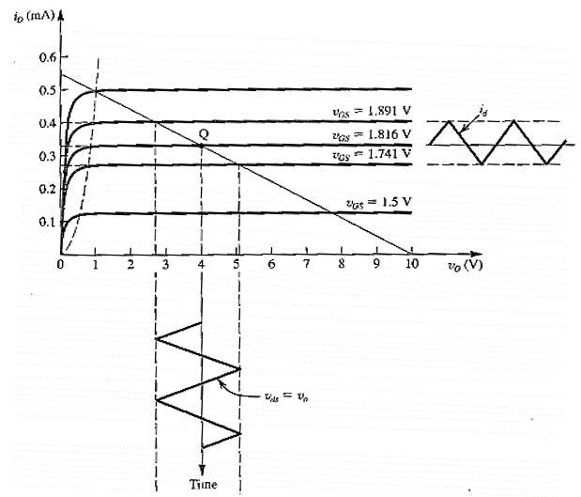
Figure 2: Amplification by MOSFET in saturation region

Task 2: To bias MOSFET in saturation region and obtain DC operating point.
- Implement the circuit shown in Figure 3. In this circuit, voltage-divider biasing configuration is used for implementation of CS MOSFET amplifier. For now, connecting capacitors is not required as AC input is not applied.
- Perform bias point analysis to find the DC operating point of MOSFET and collect relevant data to complete Table 1. Verify the mode of operation of MOSFET.

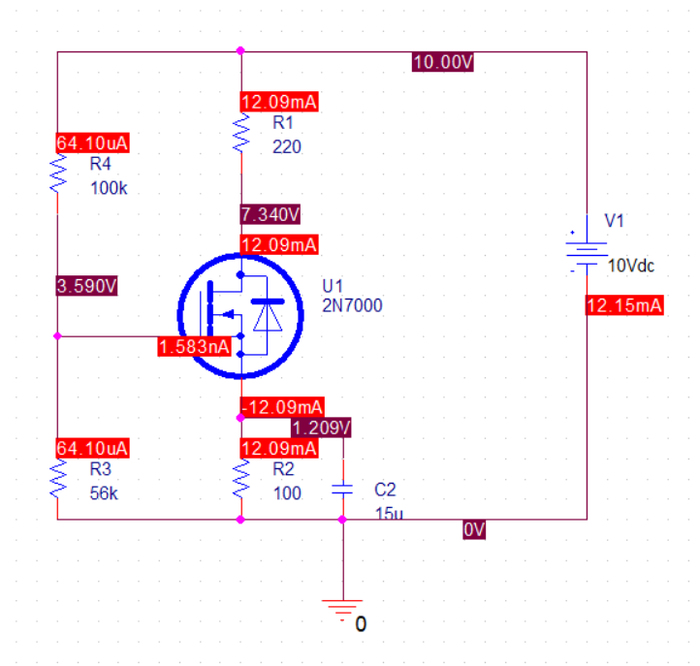

Table 1: DC analysis of CS MOSFET amplifier circuit
Parameters | Measured Value
Drain Current | 12.09mA
Drain Voltage | 7.34V
Gate Voltage | 3.59V
Source Voltage | 1.209V
Drain-to-Source Voltage | 6.131V
Gate-to-Source Voltage | 2.381
Mode of Operation | Saturation Region
Figure 3: Common source MOSFET amplifier circuit
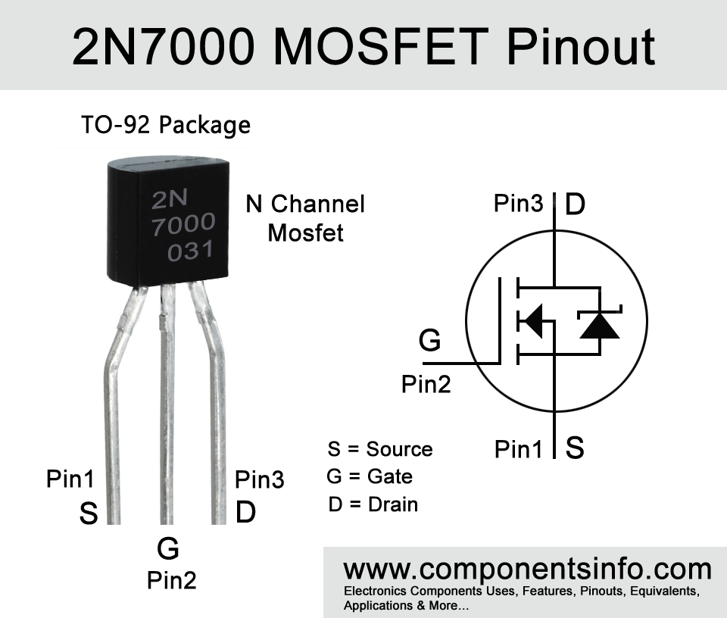
Figure 4: 2N7000 Terminals

AC Analysis of Common Source MOSFET Amplifier
The MOSFET behaves as a voltage-controlled current source in saturation region. It accepts a signal V_{gs} between gate and source and provides a current g_{m,}V_{gs} at the drain terminal. g_{m} is the trans-conductance of MOSFET as determined in Lab 08 using Id Vs Vgs curve. The input resistance of this controlled source is very high—ideally, infinite. The output resistance ro that is, the resistance looking into the drain—also is high, and is infinite for ideal MOSFETs in saturation region. This is highlighted in Figure 4 by blue box. `
For AC analysis, MOSFET in figure 3 is replaced by small signal model of MOSFET. R_{G} is the equivalent resistance of (R1||R2) used for biasing. R_{L} will be included in circuit only when amplifier is loaded.
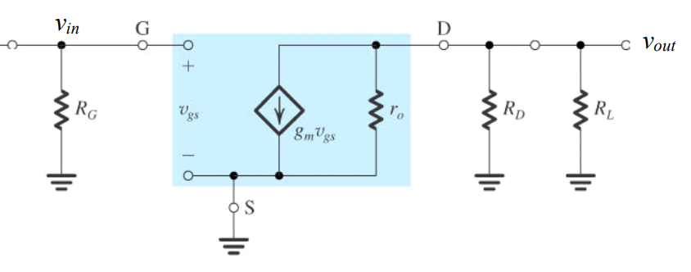
Figure 5: Small signal model of the circuit shown in Figure 3
Characteristic parameters of CS amplifier can be given as:
- AC Voltage Gain Av is defined as
Here, Vo and Vi are output and input voltages which can be measured as rms, peak or peak-to-peak.
From model, the AC voltage gain of a CS amplifier (under no-load) can be calculated using:
Where, transistor trans-conductance g_{m} can be calculated as
- Input Resistance, Ri, is that of the amplifier as seen by the input signal and mathematically it can be given as
- AC Output Resistance, Ro, for CS amplifier can be approximated to

Task 3: To calculate CS MOSFET amplifier characteristic parameters
- Using the values obtained by DC analysis in Table 1, estimate the characteristic parameters of MOSFET amplifier and fill in Table 2.
Calculation

For gm:
$$g_{m}=\frac{2×12.09 mA}{0.281}≈0.086 S$$
FOR Av:
Av = –gm × RD = –(0.0860 × 220) = –189.2
for input resistance:
$$R_{i}=\frac{R_{3}⋅R_{4}}{R_{3}+R_{4}} \\ R_{i}=\frac{\left(56k)(100k\right)}{56k+100k} \\ R_{i}=\frac{5600000}{156000}=35.9 kΩ$$

Table 2: AC analysis of CS MOSFET amplifier circuit
Characteristic Parameters | Estimated Values
Trans-conductance: gm | 0.0860
Voltage Gain: Av | -18.92
Input Resistance: Ri | 35.9k
Output Resistance: Ro | 220

Task 4: To implement CS MOSFET amplifier circuit and experimentally determine its characteristic parameters

Amplifier Voltage Gain Av
- Modify the implemented circuit to apply AC input of 20mV rms at 5 kHz frequency to the amplifier.
- Obtain input and output voltage waveforms. Add capture of the obtain plots and comment on magnitude and phase of the output voltage.
Observation:
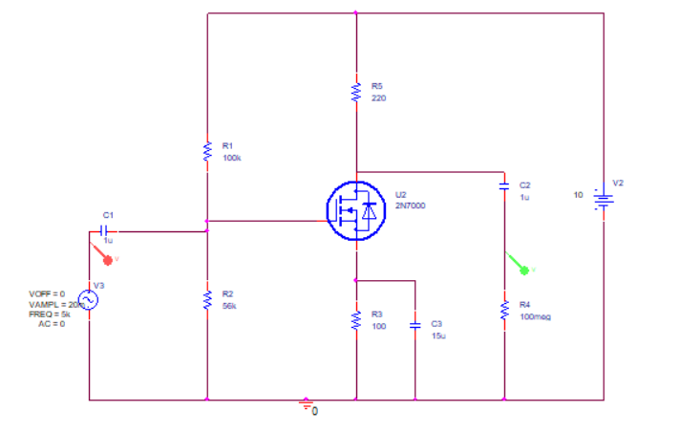
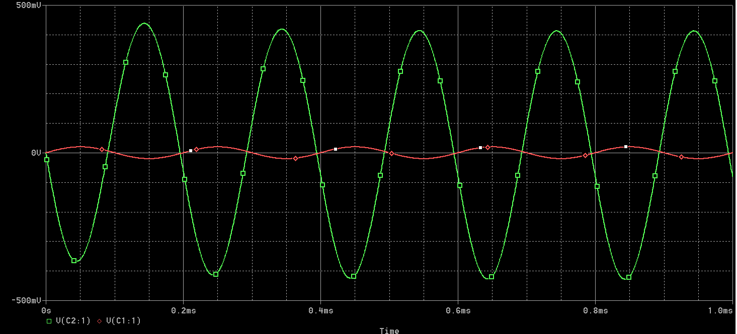
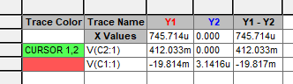
OBSERVATION:
We see the output at max reaches around 412mV. The applification factor is about 20.6 times.
Phase shift of 180 degrees is also observed. We know that when Vg increases, the drain current also increases, so the drop against drain resistor also increases, which causes Vd to go down.

- Compute voltage gain (unloaded) and fill in Table 3. Associate sign to represent phase shift.

Amplifier Input Resistance Ri
To determine amplifier input resistance, we can consider the two-port network model of amplifier as shown in Figure 5. Here, the input impedance Zi or Ri is the resistance seen from the input port of amplifier which is the ratio of input voltage and input current.
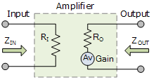
Figure 6: Representation of amplifier input and output resistance
When a source is connected at this input port, the network can be represented by Figure 6. This is used to determine the input resistance using voltage divider rule if source voltage Vs and source resistance Rs are known. Since we have ideal AC input voltage source, we can connect an external resistance to experimentally determine this unknown input resistance of amplifier.
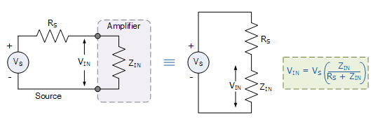
Figure 7: Circuit for experimental determination of input impedance of amplifier
- Connect a measurement resistance (Rs=10kΩ) at input side of amplifier after AC source with Vsig 20mV rms (same as previous part). Measure the voltage Vi input to the amplifier after this resistor.
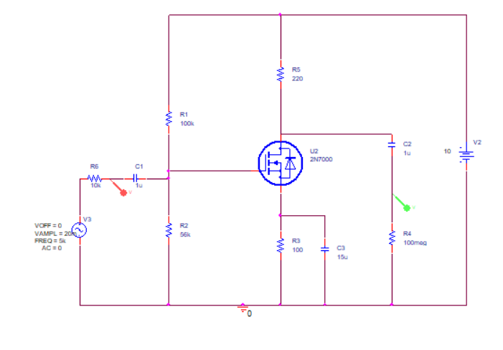
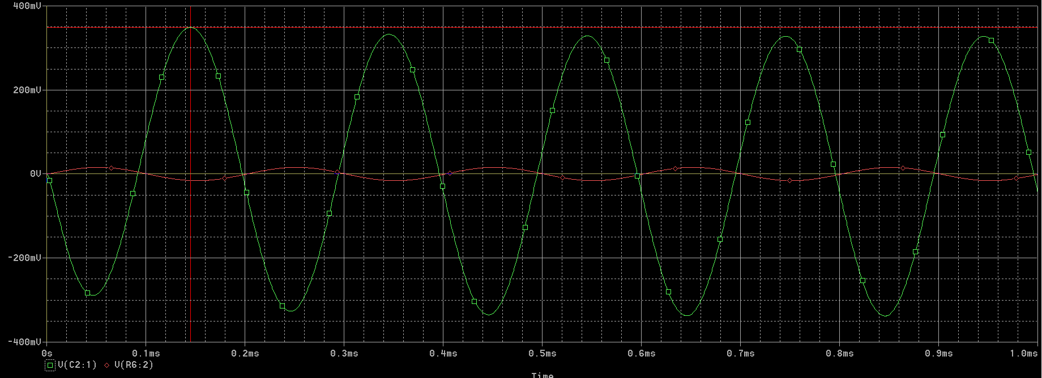
- Note down the measurements in Table 3 and calculate the input resistance of amplifier.

Amplifier Output Resistance Ro
When amplifier is loaded (load resistor R_{L} is connected at the output port), the output side network of amplifier can be represented by Figure 7. When output voltage and load resistor are known, the amplifier output impedance can be determined using voltage divider rule.
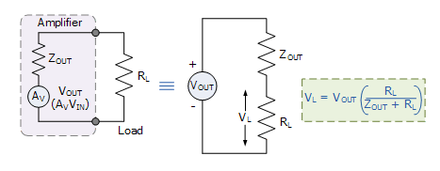
Figure 8: Circuit for experimental determination of amplifier output impedance
- Remove the input measurement resistance once again and directly apply the AC voltage from source to amplifier input terminal.
- To determine the amplifier output impedance, connect a load resistor of 1kΩ at the output port of amplifier.
- Measure this loaded output voltage and note down in Table 3. Using the collected data, compute the output resistance Ro.
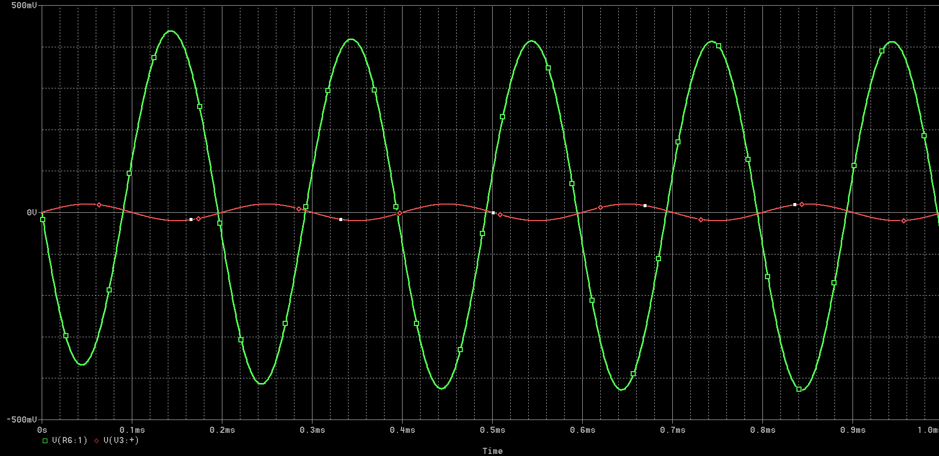

Table 3: Data table for experimental determination of CS amplifier characteristic parameters
Characteristic Parameter | Values | Required Measurements | Measured Values
Amplifier Voltage Gain: Av (Unloaded) | 20.6 | Input Voltage: Vi | 20mV
Amplifier Voltage Gain: Av (Unloaded) | 20.6 | Output Voltage (Unloaded): Vo | 412mV
Amplifier Input Resistance: Ri | 37.62k | Measurement Resistor: Rs | 10k
Amplifier Input Resistance: Ri | 37.62k | Source Voltage: V_{Sig} | 20mV
Amplifier Input Resistance: Ri | 37.62k | Input Voltage: Vi | 15.86mV
Amplifier Output Resistance: Ro | 216 | Output Voltage Unloaded: Vo | 412mV
Amplifier Output Resistance: Ro | 216 | Load Resistor: R_{L} | 1k
Amplifier Output Resistance: Ro | 216 | Output Voltage Load: V_{L} | 338mV

- Compare the experimentally determined and calculated values of gain, input resistance and output resistance of CS amplifier.
Voltage Gain: 18.92 vs 20.6 = 9% difference
Input Resistance: 35.9kΩ vs 37.62kΩ = 4.8% difference
Output Resistance: 220Ω vs 216Ω =1.9.% difference

- For the no load case, vary the input signal from 20 mV to 150 mV and observe the changes.
The amplifier operates linearly for input signals below 80-100 mV. When the input amplitude exceeds the linear range, the MOSFET transitions from the saturation region into either the triode region (during positive input peaks) or the cutoff region (during negative input peaks), resulting in clipped or distorted output. This demonstrates that proper DC biasing is critical for maximizing the amplifier's linear operating range.

20m input:
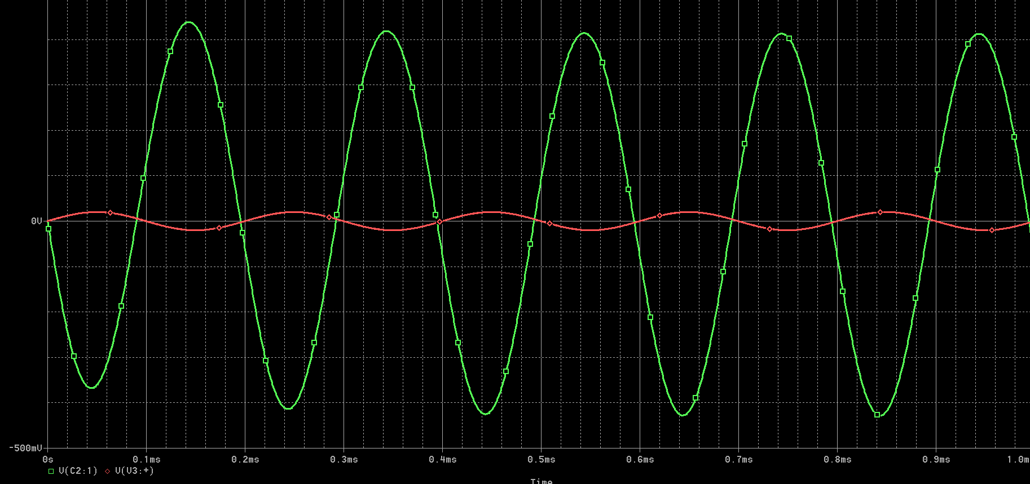
60mV input:
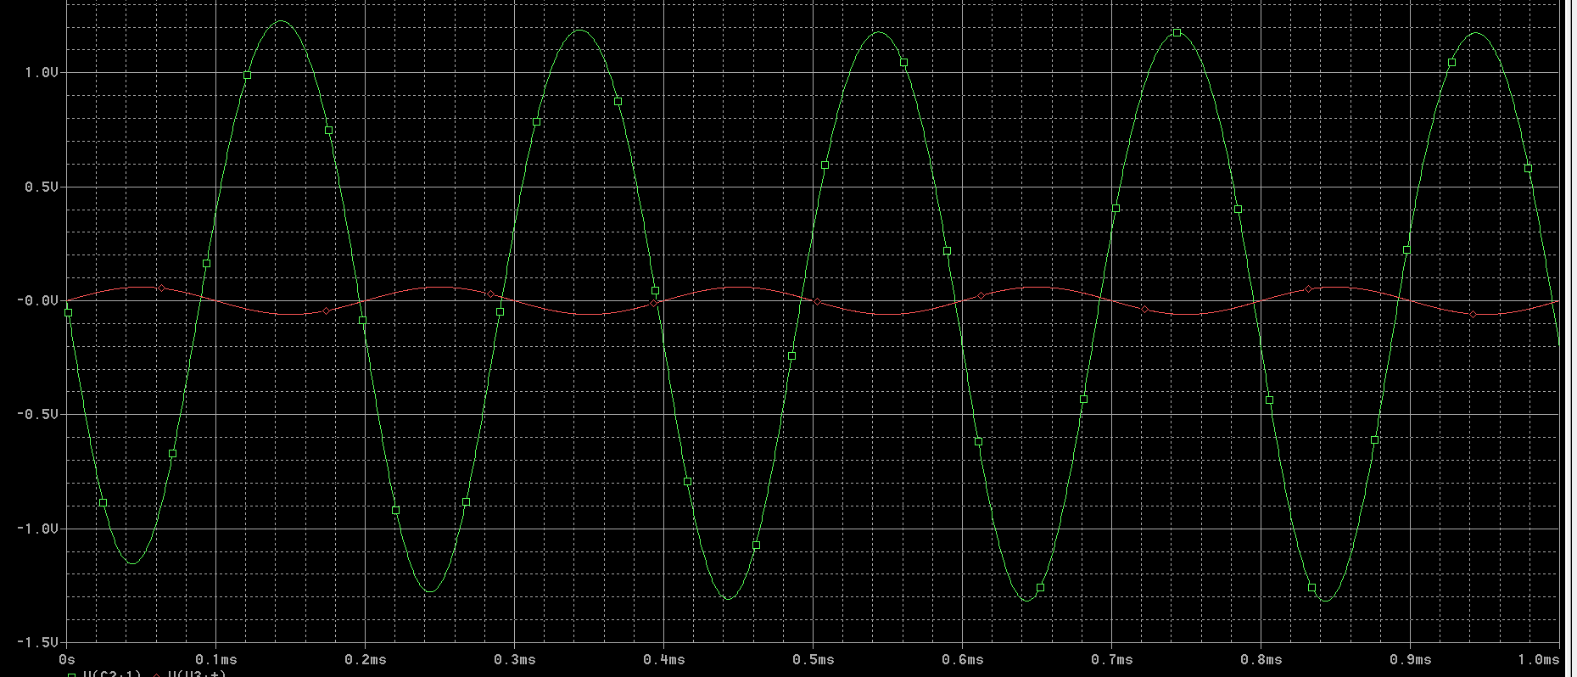
120mV input:
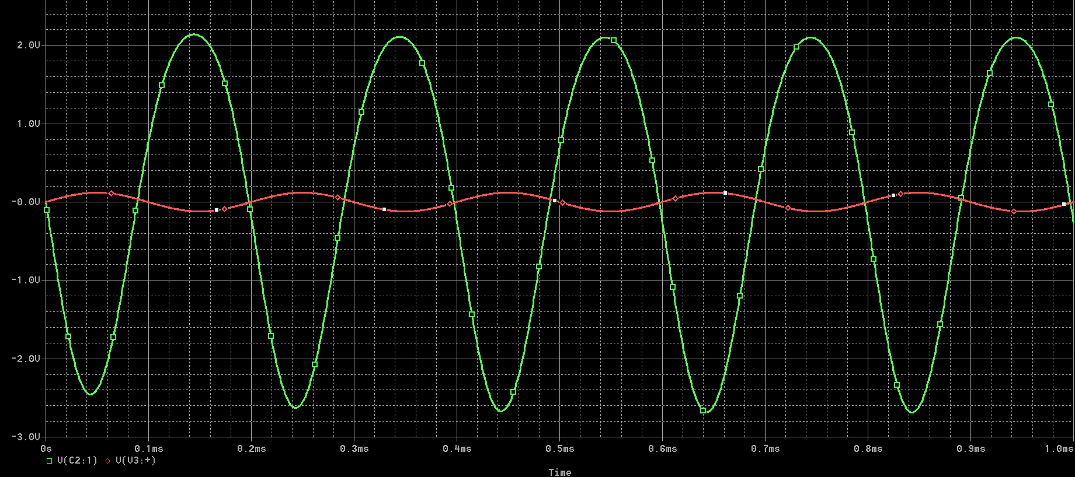
150mV input:
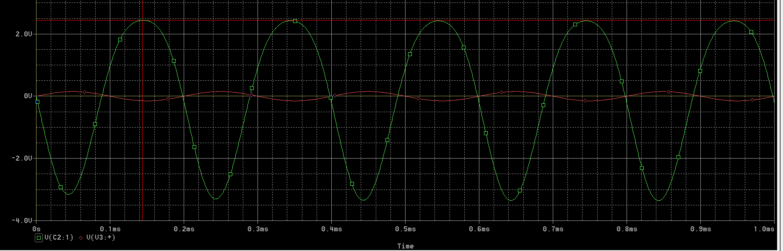

Task 5: To examine the effect of loading on CS amplifier voltage gain

- Using the measured loaded amplifier output voltage V_{L} (noted in Table 3 when 1kΩ load resistor is connected), determine loaded gain of amplifier A_{V_L} i.e., the ratio of output voltage and input voltage.
- Write mathematical expression to determine amplifier loaded gain in terms of circuit parameters from the small signal model of Figure 5 and use this expression to compute loaded voltage gain. Compare your experimental and mathematical values of loaded voltage gain.
Avl = VL / Vi = 339mV / 20mV = 16.95
Table 4: Determination of amplifier loaded voltage gain
Loaded Voltage Gain (Experimental) | -16.95
Loaded Voltage Gain (Expression) | Avl = -gm × [(RD × RL)/(RD + RL)]
Loaded Voltage Gain (Calculated) | -15.51
-ve sign means 180 degree phase shift.

- Comment about the effect of loading on amplifier gain.
Loading reduces the CS amplifier voltage gain by approximately 18% (from 20.6 to 16.95). This occurs because the load resistor RL appears in parallel with the drain resistor RD, reducing the effective output resistance. The loaded gain is 82% of the unloaded gain, demonstrating that proper impedance matching is essential for maintaining amplifier performance in practical applications

Post-Lab
Task 6:
By now, we have learned to use both BJT and MOSFET as an amplifier, what is the difference between MOSFET and BJT Amplifier? Which one is better and why?
The main difference is how they're controlled: BJTs need actual current flowing into the base to work, while MOSFETs just need voltage at the gate with basically zero current draw.
Key Differences:
- Input Impedance: MOSFETs have high input resistance, so they barely load down your signal source. BJTs are way lower than MOSFETs.
- Power Consumption: MOSFETs are very efficient since the gate doesn't pull any current. BJTs constantly need base current, which wastes some power.
- Gain: BJTs usually give you better voltage gain because they have higher transconductance.
- Speed: MOSFETs are faster at switching, which is why they dominate in digital circuits and power electronics.
Which is Better?
It completly depends on what you're doing. MOSFETs are great when you need low power consumption, high input impedance, or fast switching i.e. digital processes. BJTs are better when you need really high gain or precise linear amplification. Each one has its own use, there's no clear basis upon which one could be said better over the other.

Assessment Rubric
Lab 10
MOSFET Common Source Amplifier
Name: | Student ID:

Points Distribution

Task No. | LR1/2  Simulation/Hardware Performance | LR 4  Data Collection | LR 5  Plots | LR 6  Calculation | LR 10  Analysis
Task 1 | /4 | - | /8 | - | -
Task 2 | /8 | /8 | - | - | -
Task 3 | - | - | - | /8 | -
Task 4 | /12 | /8 | /8 | /4 | /8
Task 5 | - | - | - | /6 | /6
(Post Lab)  Task 6 |  |  |  |  | /8
 | /24 | /16 | /16 | /18 | /22
CLO Mapped | CLO 3 | CLO 1 | CLO 3 | CLO 1 | CLO 1

Affective Domain Rubric |  | Points | CLO Mapped
AR 4 | Report Submission | /4 | CLO 4

CLO – (LDL) | Total Points | Points Obtained
CLO1 – Psy3 | 56
CLO3 – Psy4 | 40
CLO4 – Aff-3 | 04
Total | 100

For description of different levels of the mapped rubrics, please refer the provided Lab Evaluation Assessment Rubrics and Affective Domain Assessment Rubrics.

